**Annexure - B**

**Pre-requisites for accessing VIDAL HEALTH TPA Web Application:**

Application Supports IE/Mozilla/Chrome/Safari user has to **ensure the Pop-Up blocker is turned off**.

***(Process is mentioned below)***

**Using Internet Explorer Browser**

Under Tools Pop-up Blocker, you can notice the following menu option either Turn off Pop-up Blocker or Turn on Pop-up Blocker.



**Procedure for accessing VIDAL HEALTH TPA Web Application:**

User to visit our website www.vidalhealthtpa.com and employee will select **Individual** login under the login tab

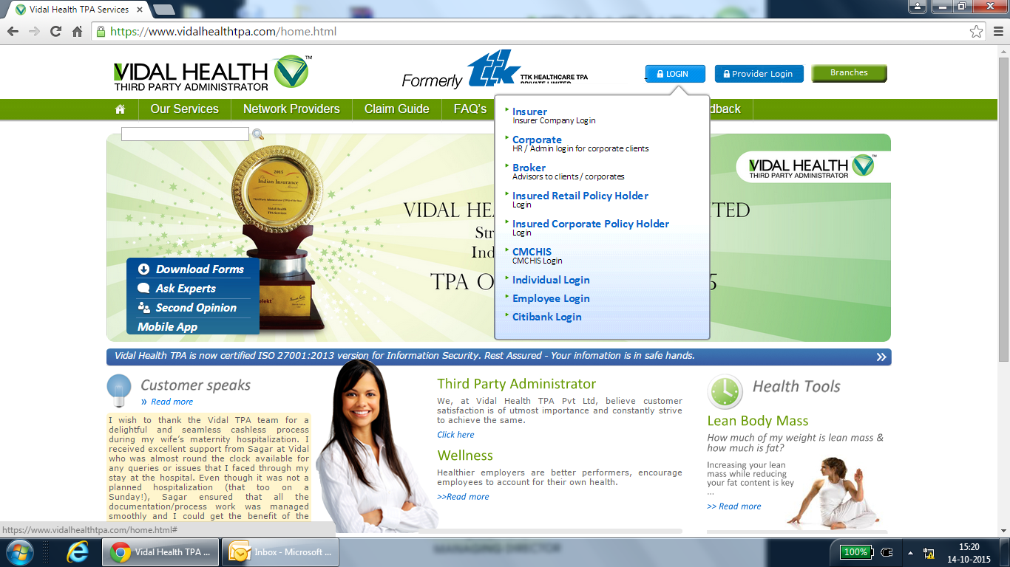

Select Vidal Health TPA ID

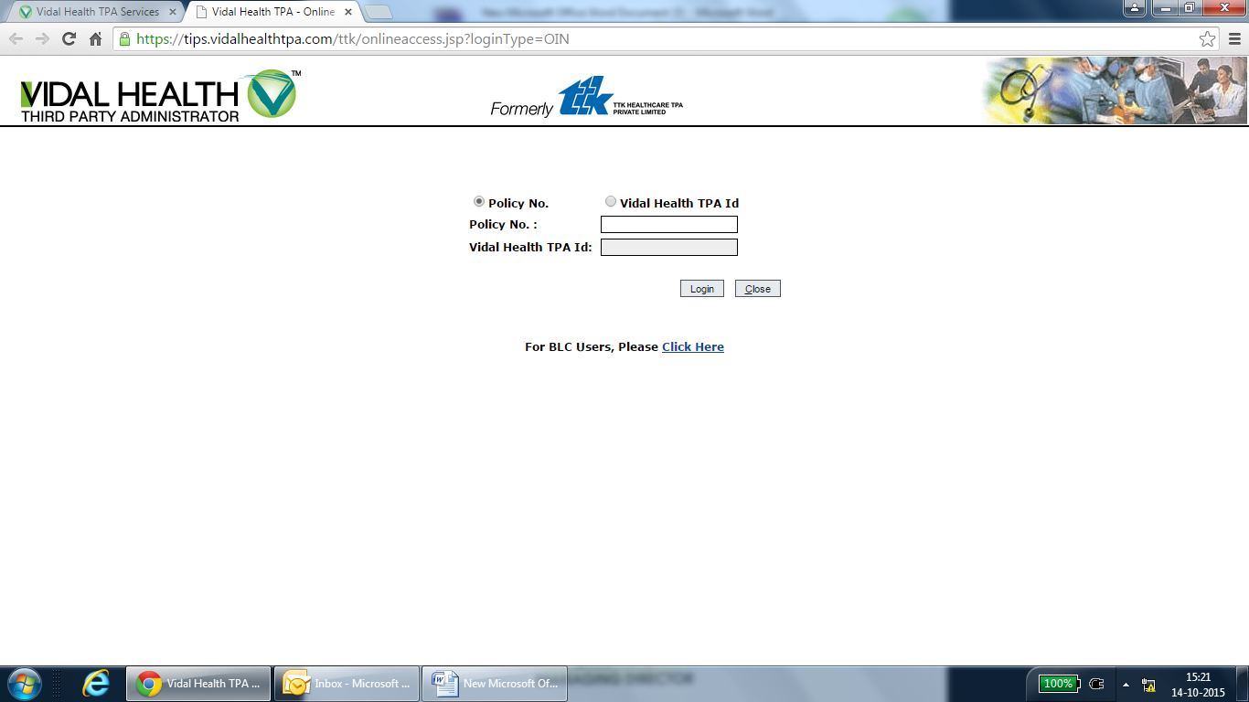

Enter your Vidal Health TPA ID , given the xl sheet against employee number wise.

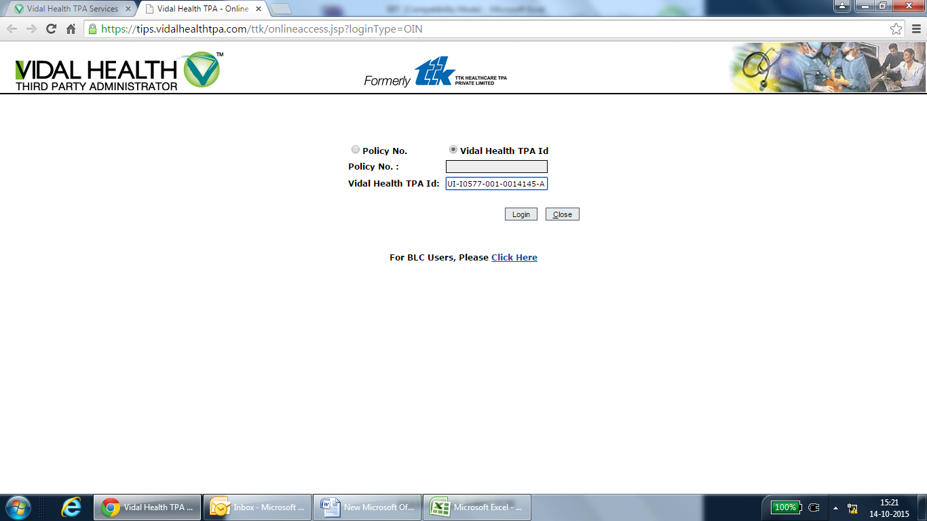

Now, you view / download your e. Card as well see the pre-auth /claim status

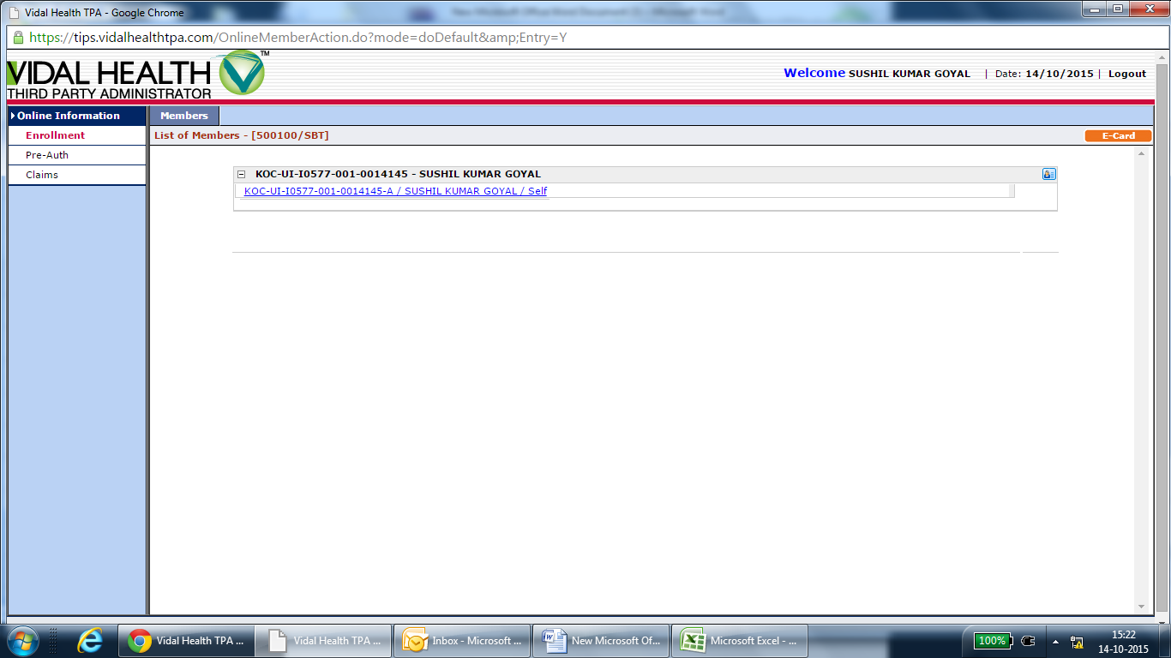

E.card is download and print out can be taken.

